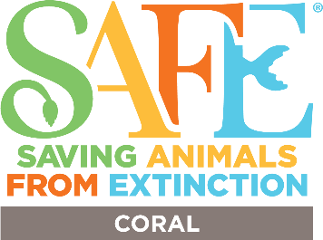
Statement of Financial Commitment
Join making significant Conservation impact! Your contribution to the SAFE Coral program supports coral conservation efforts across the US and the world.
We recognize and celebrate our donors in a variety of ways. Funding contributions are welcomed at a variety of levels:
CORAL CHAMPION - $20,000+

CORAL HERO - $15,000

CORAL GUARDIAN - $10,000

CORAL FAN – up to $5,000

SAFE Coral Contribution Details:
Date:
Organization:
Contact Name:
Email:
Donation Amount:
One-Time Donation: Recurring: Timing of Contribution:
Contributions are accepted by check.

To be invoiced, contact Bfirchau@aza.org

Please make payable to : Omaha’s Henry Doorly Zoo
In the memo place: SAFE Coral program Partner Contribution

Send checks to:
Omaha’s Henry Doorly Zoo and Aquarium
AZA SAFE Coral Program
ATT: Anne John
3701 S 10th Street
Omaha, NE 68107

