Instructions:
For each of the statements and numbers, you can either print this table directly and cut up the statements OR copy these and put them in your own format, having all pieces the same size, will likely help reduce folks using size to pick matches rather than guessing on actual numbers.

Recommendation is to use a felt board or magnetic board and place the statements and the numbers in two separate sections and ask folks to match the statement with the correct numerical value. It is recommended to not do more than 10 facts and numbers, but a variety of options are included and post-activity conversations can be curated based on the facts you choose to include.
- If you would like to focus on the Florida Reef Tract Rescue Project, review the information found in the Resource Hub at this website.

The third column provides some supporting resources and further information that facilitators can use to take the conversations further.

Coral Statement/Fact | Number Associated | Further Exploration & Links to Supporting Resources
Number of chemical compounds discovered in reefs with potential to develop new medications. | 20,000 | - Coral Reefs show promise in providing medications to combat inflammatory diseases, cancer and bone repair (Cooper et al, 2014)  - Almost 1000 new compounds are found each year, because reefs. It is believed that because corals and the other animals that make up the reef cannot move, they must use more chemical defenses to protect themselves (Clark, 2017)  - Coral Reef Alliance - Reefs & Medicine
What percent of rescued Florida Reef corals are cared for by AZA zoos and aquariums? | 80 | - The FRTRP Dashboard is a good place to get the most recent numbers for this (Coral Monitoring Dashboard)
Number of Florida Reef coral species that are part of the Florida Reef Tract Rescue Project | 20 | - The FRTRP Dashboard is a good place to get the most recent numbers for this (Coral Monitoring Dashboard)
Percent of marine species found in coral reefs | 25 | - NOAA Coral Reefs Fast Facts
What percent of the ocean do coral reefs cover? | < 1 | - Reefs support 25% of marine life, but cover less than 1% of the ocean floor. (Reef World Foundation)  - Pair this with the above fact as well.
Economic benefit to the US from services provided by coral reefs, in billions of dollars | 3.4 | - Includes fisheries, tourism, protection of coastal areas. (NOAA fast facts)  - Additional resources on services (NOAA)
Number of people that benefit from coral reefs (in billions) | 1 | - Most recent data from this was in 2020 (Coral Reef, Resource Watch Dashboard)  - The linked dashboard above also gives some additional great information on benefits of and threats to coral reefs globally
How fast do most branching stony corals grow on average each year? (in centimeters) | 10 | - These numbers can vary, stony plate corals tend to grow the slowest, as little as 0.5 cm/year.  - For branching coral, 10 cm/year is about how fast our hair grows.  (NOAA Facts)
How many years has the Florida Coral Reef existed? | 10,000 | - The Florida coral reef formed at the end of the last ice age as sea levels began to rise again. (Florida Department of Environmental Protections)
In miles, how long is Florida’s Coral Reef? | 350 | - The reef runs along the coast of FL from the Dry Tortugas National Park to St. Lucie inlet in Martin County (Discover Florida’s Reefs)
How many different species of reef building coral live in the Florida Coral Reef? | 40 | - Discover Florida’s Reefs  - Consider highlighting the 20 species that are threatened/endangered here
On average, how much of a temperature increase (in ℉) is needed to trigger a bleaching event? | 4 | - Facts and History of FL reefs
According to the fossil record, how many millions of years ago did the first coral appear? | 240 | - Reefs began forming around 240 million years ago, today’s established coral reefs are between 5-10,000 years old. (Reef World Foundation)

Additional Resources/Take it Further
- NOAA - Ten Ways I can protect Coral Reefs
- NOAA - Land-based Pollution impacts to Coral Reefs
  - For organizations not along the coast, use watersheds as a way to help connect your guests to the Florida Reefs (Mississippi Watershed → Gulf of Mexico)

Consider sharing this image if you want to chat with folks further about the work of AZA and the FRTRP. If your organization does not house Florida Reef Tract corals, perhaps highlight those that are closest to you.

You may also be part of an organization that helps support this project but does not house any species. This can be a great way to make connections to your location and coral reefs which may be far away from your space.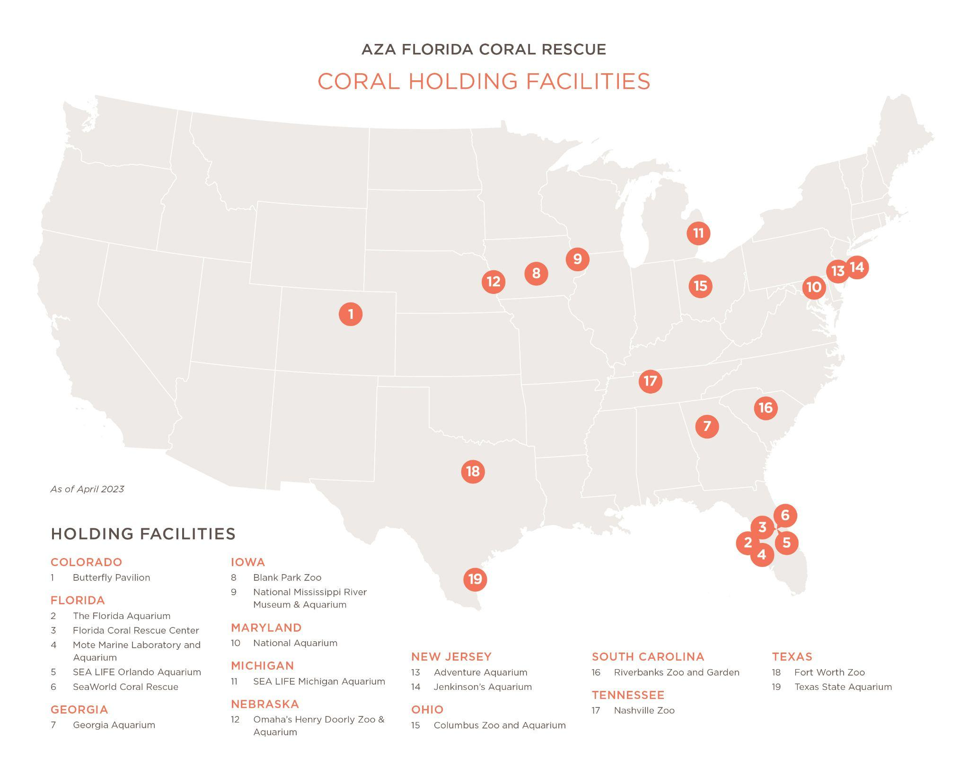

Felt Board/Magnetic Board
See below for a suggested format for the felt board/magnetic board

Statement Pieces

Number pieces

